State of Alabama Department of Transportation Master Agreement
.:·.,....·tQ..N....:t. f""fiJ"r,(;:'[•,�.•!i.··•,rf·Q•..8....M,...A,.,.J:.I,Q,Dl.''--�"'1fi,$i;J'''?1.!li;,.,,,,0Il!1fii,,J*,. j1!i:01;�,"\,l'� �l\ii""ffi-�-'"ii;'¾!,. ,,_!l'.'?._�l!c'lll\,.,•"';f_,;�..�s1,"\',,ji,•-if.fu\'.' 'lfe 'lt",j\'0t;ii;MIl ,. '· ,
MASTER AGREEMENT NUMBER: 24-014
Begin Date: 5/16/2026 Expiration Date: 5/15/2027
Vehicle Detection for Hybrid Video, Microwave and Radar Detection Systems

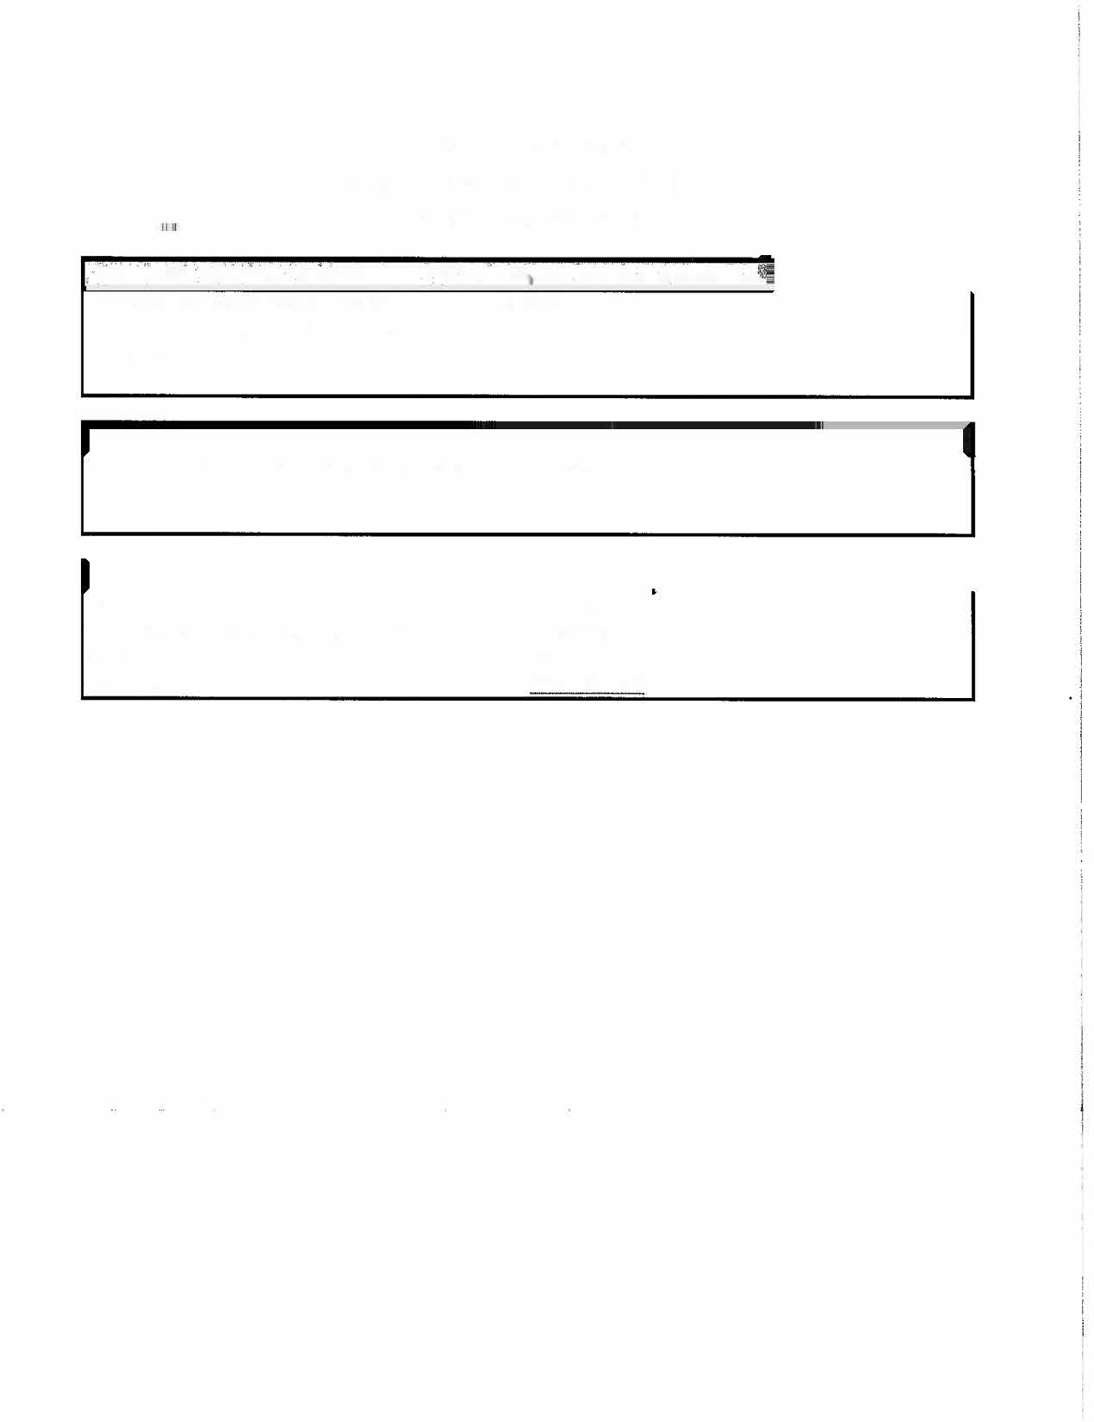



Name/Address:
VC000051647 Southern Lighting & Traffic Systems 113 Industrial Park Dr.
Cummins GA. 30040

Contact: Craig Carrow VP
770-205-9007

Line#  . |  |  | � | . | •. | Description | .. | < | .•  ... | .  Manufaturer  . . • .. | .Unit Price
1 |  |  | APPROVED SYSTEMS REQUIRED TO PROVIDE VEHICLE DETECTION, SYSTEMS TO BE PROVIDED AT% DISCOUNT OFF UST PRICE. VENDOR MUST LIST THE UNIT PRICE FOR THIS LINE ITEM AS A PERCENTAGE OFF LIST PRICE IN THE UNIT PRICE FIELD AND THE MANUFACTURER IN THE BLANK SPACE PROVIDED: , FAILURE TO ENTER THE PERCENTAGE DISCOUNT  IN THE UNIT PRICE FIELD WILL CAUSE THE TITB TO BE REJECTED. |  |  |  |  |  |  | Econollte | 25% Discount
 |  |  | PARTS AND COMPONENTS REQUIRED TO REPAIR VEHICLE DETECTION EQUIPMENT. PARTS TO BE PROVIDED AT% DISCOUNT |  |  |  |  |  |  | Econollte | 25% Discount
2 |  | OFF LIST PRICE. VENDOR MUST LIST THE UNIT PRICE FOR THIS LINE ITEM AS A PERCENTAGE OFF LIST PRICE IN THE UNIT |  |  |  |  |  |  |  | Econollte | 25% Discount
. |  |  | PRICE FIELD AND THE MANUFCATURER IN THE BLANK SPACE PROVIDED: , FAILURE TO ENTER THE  PERCENTAGE DISCOUNT IN THE UNIT PRICE FIELD Will CAUSE THE TITB TO BE REJECTED. |  |  |  |  |  |  | Econollte | 25% Discount
. |  |  |  |  |  |  |  |  |  | Econlite | $100 Per Hour
3 |  | - LABOR, COST PER HOUR TO REPAIR VEHICLE DETECTION EQUIPMENT, VENDOR MUST LIST THE UNIT |  |  |  |  |  |  |  | Econlite | $100 Per Hour
 |  |  | PRICE FOR THIS LINE ITEM AS THE HOURLY REPAIR RATE, |  |  |  |  |  |  | Econlite | $100 Per Hour
-  4 |  |  | TECHNICAL SUPPORT FOR SYSTEMS, 1 DAV {STATEWIDE). 1 SERVICE TECHNICIAN INCLUDING All TRAVEL, LODGING, AND |  |  |  |  |  |  | Econllte | $250.00 Per Day
 | _· |  | MEALS, (OPTIONAL) |  |  |  |  |  |  | Econllte | $250.00 Per Day
.  s |  |  | FREIGHT

