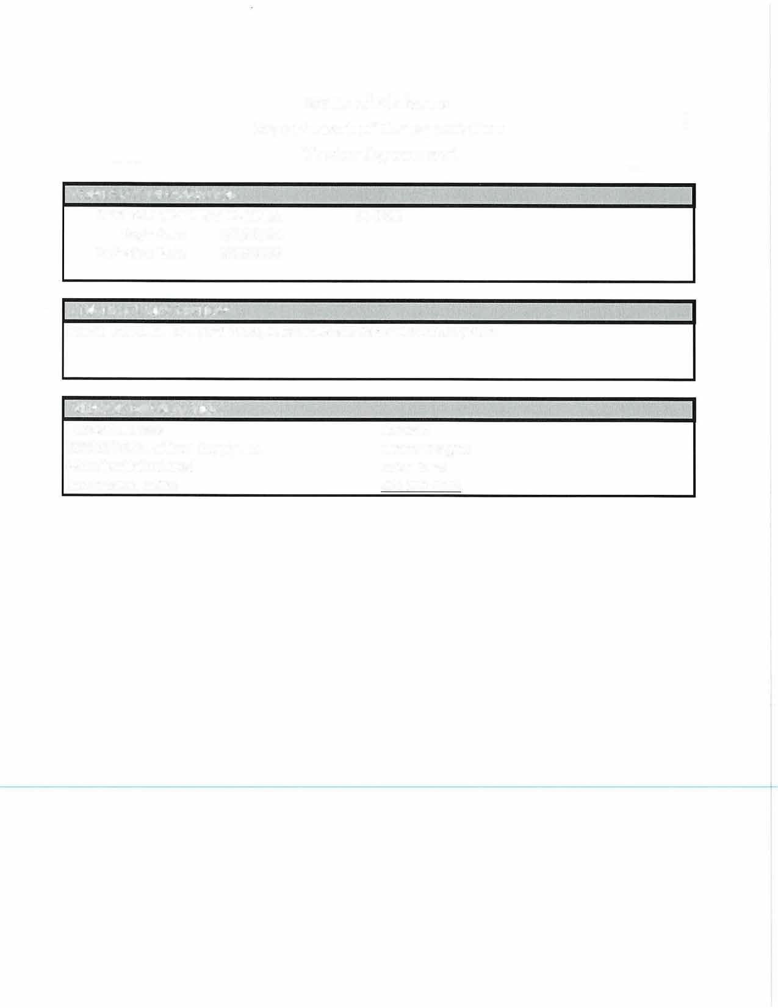



CONTRACT INFORMATION

State of Alabama Department of Transportation Master Agreement

MASTER AGREEMENT NUMBER:
Begin Date: 5/16/2026 Expiration Date: 5/15/2027
24-016

CONTRACT DESCRIPTION
Vehicle Detection for Hybrid Video, Microwave and Radar Detection Systems

VENDOR INFORMATION

Name/Address:
VC000042943 Utilicom Supply LLC. 4400 Shackleford Road
Norcross GA. 30093

Contact: Tammy Coggins Inside Sales 205-995-2855

Line# | Description | Manufacturer | Unit Price
1 | APPROVED SYSTEMS REQUIRED TO PROVIDE VEHICLE DETECTION. SYSTEMS TO BE PROVIDED AT% DISCOUNT OFF LIST PRICE. VENDOR MUST LIST THE UNIT PRICE FOR THIS LINE ITEM AS A PERCENTAGE OFF LIST PRICE IN THE UNIT PRICE FIELD AND THE MANUFACTURER IN THE BLANK SPACE PROVIDED: FAILURE TO ENTER THE PERCENTAGE DISCOUNT  IN THEUNIT PRICE FIELD WILL CAUSE THE TITB TO BE REJECTED. | Teledyne/Flir | 10% Discount
2 | PARTS AND COMPONENTS REQUIRED TO REPAIR VEHICLE DETECTION EQUIPMENT. PARTS TOBE PROVIDED AT% DISCOUNT OFF LIST PRICE. VENDOR MUST LIST THE UNIT PRICE FOR THIS LINE ITEM AS A PERCENTAGE OFF LIST PRICE IN THE UNIT PRICE FIELD ANDTHE MANUFCATURER IN THE BLANK SPACE PROVIDED: . FAILURE TO ENTER THE  PERCENTAGE DISCOUNT IN THE UNIT PRICE FIELD WILL CAUSE THE TITB TO BE REJECTED. | Teledyne/Flir | 10% Discount
3 | LABOR, COST PER HOUR TO REPAIR VEHICLE DETECTION EQUIPMENT. VENDOR MUST LIST THE UNIT PRICE FOR THIS LINE ITEM AS THE HOURLY REPAIR RATE. | Teledyne/Flir | $90 Per Hour
4 | TECHNICAL SUPPORT FOR SYSTEMS, 1 DAY (STATEWIDE). 1 SERVICE TECHNICIAN INCLUDING ALL TRAVEL, LODGING, AND MEALS. (OPTIONAL) |  | $1,100 Each
5 | FREIGHT

