

- The state of Alabama has approximately 16,001 highway bridges. The Alabama Department of Transportation owns 5,762. Local agencies own 10,170 and the remining 63 bridges are owned by other agencies or private entities.

- ALDOT is responsible for ensuring all publicly accessible bridges in the state are inspected routinely in accordance with state and federal regulations. ALDOT inspects its own highways while local agencies and private owners are responsible for their inspections and are required to submit their inspection data to ALDOT.

Bridge Inspection Grading System

- All bridges are classified as Good, Fair, or Poor in accordance with the Federal Highway Administration.
- The National Bridge Inventory grades bridges on a scale of 0 – 9. Bridge Condition is determined by the lowest rating of National Bridge Inventory condition ratings for Item 58 (Deck), Item 59 (Superstructure), Item 60 (Substructure), or Item 62 (Culvert). If the lowest rating is greater than or equal to 7, the bridge is classified as Good; bridges rated 5 or 6 are classified as Fair; if it is less than or equal to 4, the classification is Poor.

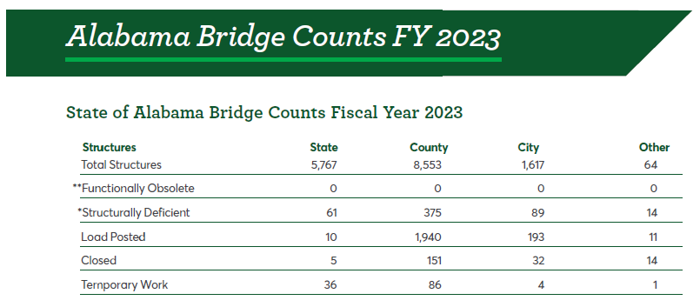

**Functionally Obsolete (FO) – The term Functionally Obsolete is no longer being tracked by the FHWA
*Structurally Deficient (SD) – as of January 2018, a bridge is considered Structurally Deficient when any component of a bridge condition has a grade of four or less

What is a “structurally deficient” bridge?
“Structurally deficient” means there are elements of the bridge that need to be monitored and/or repaired. The fact that a bridge is “structurally deficient” does not imply that it is unsafe. It means the bridge must be monitored, inspected and maintained.

What makes a bridge structurally deficient and are structural deficient bridges unsafe?
A “deficient” bridge is one with some maintenance concerns that do not pose a safety risk. A deficient bridge typically requires maintenance and repair and eventual rehabilitation or replacement to address deficiencies. To remain open to traffic, structurally deficient bridges are often posted with reduced weight limits. If unsafe conditions are identified during a physical inspection the structure will be closed.

